NFL Regular Checkout
(15vusers-1hr duration)

Conducted By: Lakshmi Chinthapalli
Sr. Performance Engineer
GSI Commerce
Date: 10/19/2010

1. DB CPU 3
2. APP CPU 4
3. Disk space free in MB 5
4. Disk space % full 6
5. Memory free in MB 7
6. Memory used in % 8
7. Terminology 9
7.1. LoadRunner Objects 9
7.2. Graph Information 9

- DB CPU

Displays measurements reported by SiteScope.

Title: DB CPU
Current Results: C:\Documents and Settings\chinthapallil\Local Sett
ings\Temp\res\res.lrr
Filters: System Resource Name = (/GSI_1/CPU sectstdb05.gspt
.net/utilization)
Group By:
Granularity: 64 Seconds

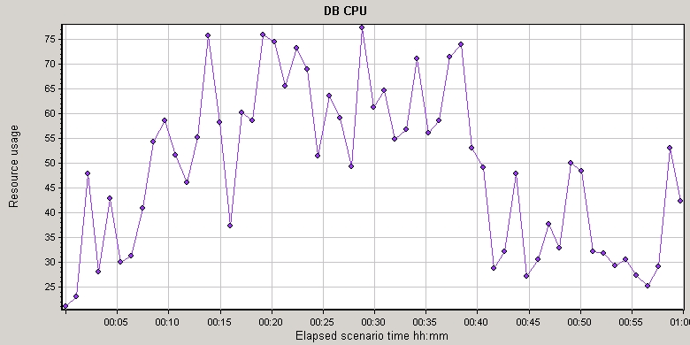

Color | Scale | Measurement | Min. | Ave. | Max. | SD
 | 1 | /GSI_1/CPU sectstdb05.gspt.net/utilization:ashprdldr01 | 8 | 48.943 | 98 | 20.424

- APP CPU

Displays measurements reported by SiteScope.

Title: APP CPU
Current Results: C:\Documents and Settings\chinthapallil\Local Sett
ings\Temp\res\res.lrr
Filters: System Resource Name = (/GSI_1/CPU Utilization on
sectstapp02.gspt.net/utilization)
Group By:
Granularity: 64 Seconds

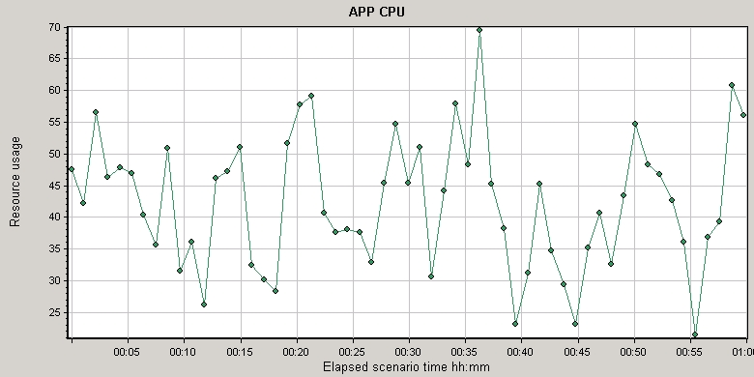

Color | Scale | Measurement | Min. | Ave. | Max. | SD
 | 1 | /GSI_1/CPU Utilization on sectstapp02.gspt.net/utilization:ashprdldr01 | 8 | 41.773 | 99 | 18.913

- Disk space free in MB

Displays measurements reported by SiteScope.

Title: Disk space free in MB
Current Results: C:\Documents and Settings\chinthapallil\Local Sett
ings\Temp\res\res.lrr
Filters: System Resource Name = (/GSI_1/Disk Space| /dev/ma
pper/vg_os-lv_root on sectstapp02.gspt.net/MB free
Group By:
Granularity: 64 Seconds

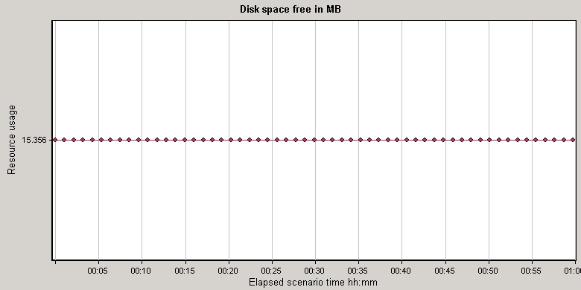

Color | Scale | Measurement | Min. | Ave. | Max. | SD
 | 0.001 | /GSI_1/Disk Space| /dev/mapper/vg_os-lv_root on sectstapp02.gspt.net/MB free:ashprdldr01 | 15356 | 15356 | 15356 | 0.0

- Disk space % full

Displays measurements reported by SiteScope.

Title: Disk space % full
Current Results: C:\Documents and Settings\chinthapallil\Local Sett
ings\Temp\res\res.lrr
Filters: System Resource Name = (/GSI_1/Disk Space| /dev/ma
pper/vg_os-lv_root on sectstapp02.gspt.net/percent
full)
Group By:
Granularity: 64 Seconds

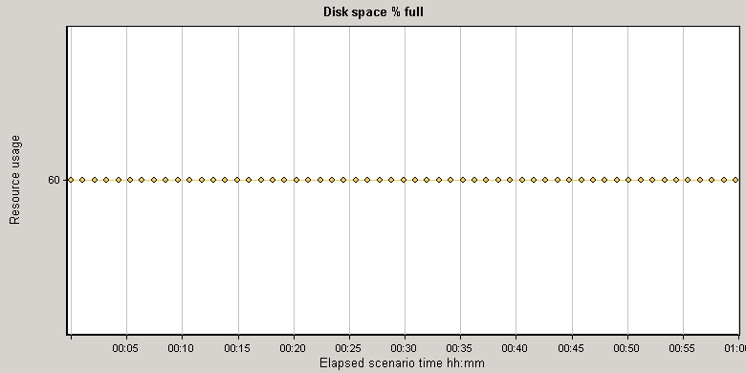

Color | Scale | Measurement | Min. | Ave. | Max. | SD
 | 1 | /GSI_1/Disk Space| /dev/mapper/vg_os-lv_root on sectstapp02.gspt.net/percent full:ashprdldr01 | 60 | 60 | 60 | 0.0

- Memory free in MB

Displays measurements reported by SiteScope.

Title: Memory free in MB
Current Results: C:\Documents and Settings\chinthapallil\Local Sett
ings\Temp\res\res.lrr
Filters: System Resource Name = (/GSI_1/Memory on sectstapp
02.gspt.net/MB free)
Group By:
Granularity: 64 Seconds

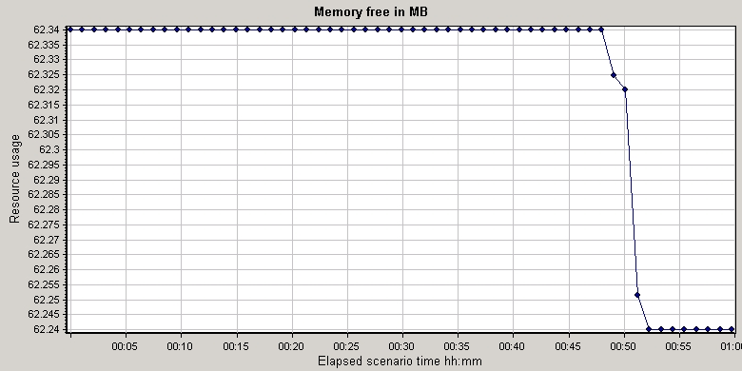

Color | Scale | Measurement | Min. | Ave. | Max. | SD
 | 0.01 | /GSI_1/Memory on sectstapp02.gspt.net/MB free:ashprdldr01 | 6224 | 6232.472 | 6234 | 3.544

- Memory used in %

Displays measurements reported by SiteScope.

Title: Memory used in %
Current Results: C:\Documents and Settings\chinthapallil\Local Sett
ings\Temp\res\res.lrr
Filters: System Resource Name = (/GSI_1/Memory on sectstapp
02.gspt.net/percent used)
Group By:
Granularity: 64 Seconds

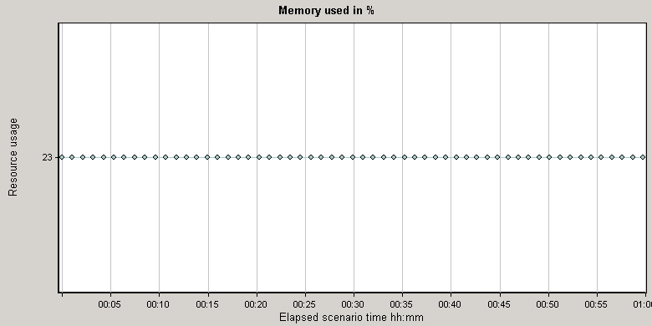

Color | Scale | Measurement | Min. | Ave. | Max. | SD
 | 1 | /GSI_1/Memory on sectstapp02.gspt.net/percent used:ashprdldr01 | 23 | 23 | 23 | 0.0

- Terminology

  - LoadRunner Objects

Term | Definition
Vuser Scripts | A Vuser script describes the actions that a Vuser performs during the scenario. Each Vuser executes a Vuser script during a scenario run. The Vuser scripts include functions that measure and record the performance of your application�s components.
Load Test | Tests a system's ability to handle a heavy workload. A load test simulates multiple transactions or users interacting with the computer at the same time and provides reports on response times and system behavior.
Run-Time Settings | Run-Time settings allow you to customize the way a Vuser script is executed. You configure the run-time settings from the Controller or VuGen before running a scenario. You can view information about the Vuser groups and scripts that were run in each scenario, as well as the run-time settings for each script in a scenario, in the Scenario Run-Time Settings dialog box.
Scenario | A scenario defines the events that occur during each testing session. For example, a scenario defines and controls the number of users to emulate, the actions that they perform, and the machines on which they run their emulations.
Scheduler | The Schedule Builder allows you to set the time that the scenario will start running, the duration time of the scenario or of the Vuser groups within the scenario, and to gradually run and stop the Vusers within the scenario or within a Vuser group. It also allows you to set the load behavior of Vusers in a scenario.
Session | When you work with the Analysis utility, you work within a session. An Analysis session contains at least one set of scenario results (lrr file). The Analysis utility processes the scenario result information and generates graphs and reports. The Analysis stores the display information and layout settings for the active graphs in a file with an .lra extension. Each session has a session name, result file name, database name, directory path, and type.
Transactions | A transaction represents an action or a set of actions used to measure the performance of the server. You define transactions within your Vuser script by enclosing the appropriate sections of the script with start and end transaction statement.
Vusers | Vusers or virtual users are used by LoadRunner as a replacement for human users. When you run a scenario, Vusers emulate the actions of human users working with your application. A scenario can contain tens, hundreds, or even thousands of Vusers running concurrently on a single workstation.

  - Graph Information

Term | Definition
Average | Average value of the graph measurement's.
Hits | The number of HTTP requests made by Vusers to the Web server.
Maximum | Maximum value of the graph measurement's.
Measurement | This is the type of resource being monitored
Median | Middle value of the graph measurement's.
Minimum | Minimum value of the graph measurement's.
Network Delay | The time it takes for a packet of data sent across the network to go to the requested node and return.
Network Path | The Network Path is the route data travels between the source machine and the destination machine.
Response time | The time taken to perform a transaction.
Scale (or granularity) | In order to display all the measurements on a single graph, thus making the graphs easier to read and analyze, you can change the scale or (granularity) of the x-axis. You can either set measurement scales manually, view measurement trends for all measurements in the graph, or let Analysis scale them automatically. The Legend tab indicates the scale factor for each resource.
Standard Deviation (SD) | The square root of the arithmetic mean value of the squares of the deviations from the arithmetic mean.
Throughput | Throughput is measured in bytes and represents the amount of data that the Vusers received from the server.
Vuser Load | When you run a scenario, the Vusers generate load or stress on the server. LoadRunner monitors the effect of this load on the performance of your application.

